

TO : | IT Department
THRU : | -
SUBJECT : | Request for Installation of Software Programs for Maintenance Supervisor Laptop
DATE : | October 28, 2025
CC : | Ken Santos

Good day!
I would like to request the installation of the following programs to my company issued laptop:
# | Application | Required Version | Purpose
1 | Autodesk AutoCAD | 2020 and up | Viewing, editing, and drawing engineering plans
2 | SketchUp Pro | 2020 and up | 3D rendering of structures and equipment layouts
3 | DIALux evo | Latest | Lighting simulation and design analysis tool
4 | CorelDraw | 2019 and up | Design & preparation of visual layouts and schematics
5 | Simurelay | Latest | Electrical circuit simulation and relay logic testing
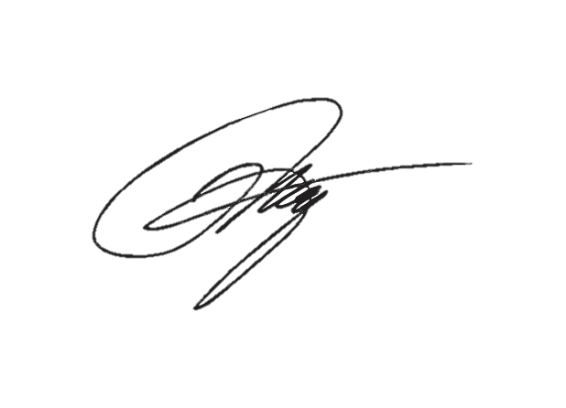
Prepared by:

Engr. Francis M. Pantaleon, REE
Maintenance Supervisor
MPFF Greenhouse San Rafael, Bulacan

